Testing the Front Panel Board

Servicing a SuperDARN Transceiver  
Step 5

Content

1. Introduction 3

2. Instructions 3

3. Conclusion 4

# Introduction

This document provides work instructions for testing the Front Panel Board in a SuperDARN transceiver box. Before attempting to implement these instructions, be sure to complete all the preceding steps in the procedure for Servicing a SuperDARN Transceiver.

# Instructions

Following are the step-by-step instructions for testing the Front Panel Board. In the case of unforeseen problems occurring, apply electronic fault-finding techniques. Refer to *Figure 1* for component and connection locations.

1. Connect the ribbon cable from the Front Panel on **P2** to the Power Distribution Board.
2. Switch on the 15 V from the switch on the front plate.
3. There are three LEDs on the FPB indicating voltages 15 V, 5 V, and 3.3 V. All three of these should be **ON**.
   1. If the 3.3 V LED is **OFF,** check the pin and regulator at **U1**.
   2. If the 5 V LED is **OFF**, check the pin and regulator at **U2**.
   3. If the 15 V LED is **OFF**, there is a fault on the 15 V line. If there hasn’t been a problem in any of the previous test steps, the fault is on the Front Panel Board, so fault-find here.

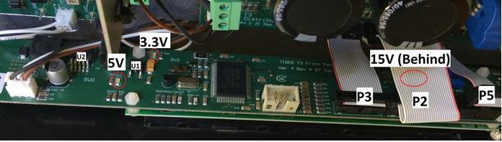

Figure . Important components and connections on the Front Panel Board.

1. There is also one row of four LEDs on the front plate face which should light up. The second row of LEDs should be off but may flash momentarily when switched on (this will depend on the firmware version).
2. Scroll using the turn knob to the voltage screen on the Front Panel LCD and check that the voltages are displaying. The voltages from the FPGA will be blank at this time. If any other voltages from the Power Distribution Board are missing, check the ribbon cable. Remember to apply 3.3 V to the relay to see the 50 V display.
3. Power off.
4. Now connect the ribbon cables at **P3** and **P5**. Power up.
5. Check that the Front Panel boots up correctly. If the Front Panel browns out or fails to start up at this point, the problem is most likely with a ribbon cable, the Lantronix Board, or the FPGA.
6. **D1** on the Lantronix board should light up if all is OK; refer to Figure 2.

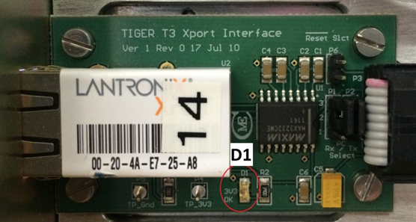

Figure . Lantronix Board LED location.

1. If all is well, power off.

# Conclusion

This concludes the work instructions for testing the Front Panel Board of a SuperDARN transceiver box. The next step in the procedure for Servicing a SuperDARN Transceiver is to test the Capacitor Board.